Mission 0

Github: <https://github.com/William-RA-Richards/AdvL5Mission0>

Screen Sizes

1400px+



1200-1400px



1000-1200px

800-1000px

600-800px

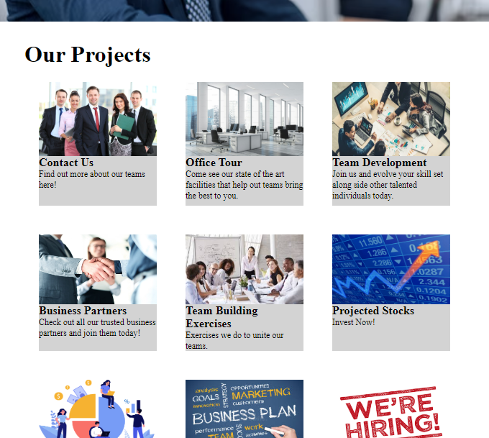

400-600px

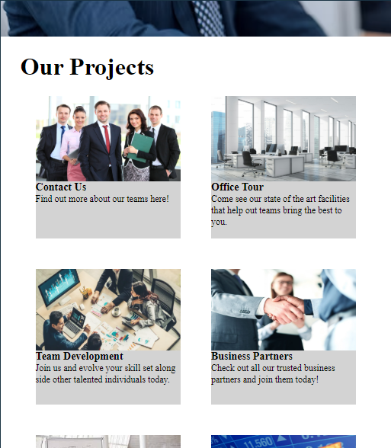

Mobile (400px or less)

With menu open

